Recently, while looking through some old boxes at home, I came across my elementary school farewell album: a class project where each of us had a page with two photos side by side. One from our first day of school at age three, and one from our last at twelve, with a short text we had written ourselves. My twelve-year-old self, apparently not content with the usual hobbies and popular books, had added a closing statement: "I think the world is currently in a very bad place. We have an economic crisis, but most importantly, we have climate change. I hope things will improve, because otherwise we are done." Future climate economist in the making, perhaps.

Figure 1. Photo of my school farewell album

As a teenager, I kept reading about climate change and grew increasingly puzzled by how most people around me seemed to carry on as normal. Did they not know? Were they sceptical? Or did they simply not care? I became convinced that the only ethical response was to change my own habits: I turned vegetarian, cut back on consumption, bought locally or second-hand where I could, and reached for eco-labelled products whenever they were available.
And yet, every summer, I was boarding a plane.
I am genuinely grateful to my parents for those trips. Beyond the stunning scenery, travelling exposed me to different cultures and ways of living, fostering in me a genuine respect for the world's diversity, and realising just how privileged my upbringing had been; something I might never have understood otherwise. But I could never quite shake the feeling that those flights were quietly undoing everything else I was trying to do. Wasn't I just living in contradiction?
If any of this sounds familiar, stick with me. Looking back, what I lacked was not the intention — it was a clearer sense of what actually matters, and why.
The invisible problem
Emissions are not easy to keep track of. Most greenhouse gases (GHGs), such as carbon dioxide (CO₂), methane (CH₄) and nitrous oxide (N₂O), are invisible to the human eye, as well as colourless and odourless. The brown haze you might spot above a city skyline on a hot summer day are other kinds of gases, such as aerosols, particulates or soot, but not CO₂. Greenhouse gases slip through entirely undetected.
Money is largely invisible to most of us too. We rarely handle cash anymore, and most of our income and spending exists only as numbers on a screen. But the key difference is that every transaction we make has a recorded price. We can check our bank statement at any time and know exactly where our money went. With carbon emissions, we have neither: we do not know the carbon footprint of most things we consume, and no one is keeping record of it on our behalf.
As climate concerns have grown, many companies have started incorporating carbon accounting into their processes and adjusted some of their practices in pursuit of sustainability. But this tends to remain an internal exercise, and since consumption still drives their economic performance, very few have ventured to pass this information on to consumers.
Some exceptions exist. Asics prints the carbon footprint of some of their shoes directly on the box, and a growing number of restaurants include emissions data alongside the calories on their menus.

Figure 2. Asics running shoe informing of its carbon footprint
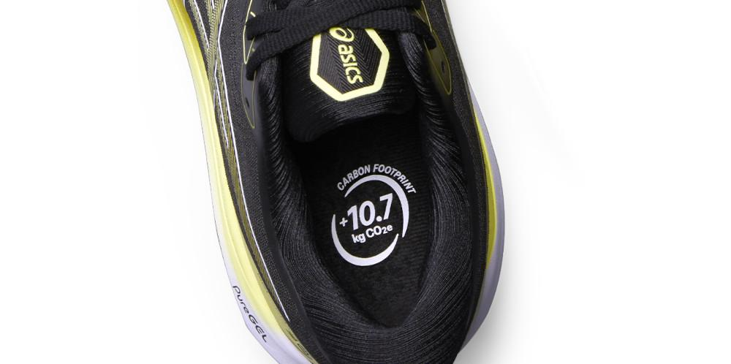
Source: Sustainable Brands.
These are encouraging steps for two reasons: they help us compare the climate impact of substitute options, and they build awareness that everything we consume carries a carbon footprint. But they fall short of giving us the full picture. Is 11kg of CO₂ for a pair of running shoes a lot? Or more importantly, if I go through three pairs a year, does that represent 0.1%, 2% or 10% of my total carbon footprint? Without a sense of scale, individual data points tell us very little. That sense of scale is exactly what we need to build next.
The carbon footprint of everything
Mike Berners-Lee's How Bad Are Bananas? (2nd ed.) offers a comprehensive guide to the carbon footprint of virtually everything we might consume — including, of course, bananas, which turn out to be quite a climate-friendly snack. The book is organised into chapters grouped by order of magnitude, ranging from under 10g CO₂e for sending an email or running a Google search, all the way up to billions of tonnes for the world's total annual footprint (54.43 billions of tons, or gigatonnes, in 2024, according to Our World in Data).
But the goal is not to memorise each individual figure. Estimating a carbon footprint means accounting for both direct and indirect emissions across the entire production chain: extraction of raw materials, manufacturing, transport, use, and disposal. For products that embed many components sourced from global supply chains, such as computers or cars, that process can be extraordinarily complex.
What the book offers instead is an intuition for scale: understanding what drives a footprint up or down, and being able to make rough but informed comparisons between different goods, or the same good produced in different ways.
The headline finding is fairly consistent across categories, the lion's share of any carbon footprint comes from fossil fuels burned to generate heat or movement. The more power required — the higher the temperature, the faster the speed — the greater the emissions, when that energy is supplied by fossil fuels rather than low-carbon sources like renewables or nuclear energy. On the other hand, the more goods or people moved by the same amount of energy — whether because the speed is low or the load is large — the lower the carbon footprint per unit delivered
Layer on top of that the carbon released through land-use change such as deforestation, the methane released by ruminants and anaerobic processes (organic matter decomposing in landfills, or flooded rice paddies), nitrous oxide from fertilisers, and emissions from industrial chemical processes like cement production, and you have accounted for the vast majority of global emissions.
In addition, the book conveys a few lessons that help paint the big picture. These, in my view, are the most valuable takeaways.
- What you see is rarely what matters most.
In recent years, many retailers from small eco-conscious shops to major supermarkets have moved to replace plastic packaging. While that is not a bad instinct, packaging typically accounts for only 2–5% of a product's total carbon footprint. And even within that small share, the picture is complicated. Plastic production is more carbon-intensive than paper or cardboard, but plastic is considerably lighter, which reduces transport emissions. Furthermore, for some products, plastic packaging preserves food better, and if that means it prevents food waste, it may actually be the lower-carbon option overall.
- Direct emissions are just one part of the story.
It is easy to feel the carbon cost of some activities. Filling a car's fuel tank, for instance, makes it tangible, all that petrol will be burned, and the CO₂ will go straight into the atmosphere. But according to Berners-Lee, the emissions that come out of the exhaust pipe are roughly matched by those embedded in the car's manufacture. Of course, that depends largely on how much you drive and for how long you keep your car.
For a smartphone, the imbalance is even starker. Around 75% of a smartphone’s footprint comes from production, 23% from the energy consumed by the networks and data centres it connects to, and only about 2% from actually charging it (though figures may vary depending on the country's energy mix). For a pair of running shoes, which we rarely wash and never plug in, the embodied share approaches 100%, almost everything has already happened by the time you lace them up.
- The same activity can have a very different footprint depending on how it is done.
Imagine you want to give a bunch of flowers to someone you love. Picked from your own garden, the footprint is close to zero; a seasonal, locally grown bunch sits somewhere between 100g and 1kg; roses or lilies grown in European hothouses or airfreighted from Africa can reach 10–30kg. Travel tells a similar story. On a route like Barcelona–Madrid or London–Glasgow, four people in a fuel-efficient car driven at a reasonable speed can match the emissions of a train journey, while a solo driver in an SUV at 150km/h comes out significantly worse than flying in economy class.
What does a common carbon footprint look like?
Now that we have a better idea of what drives carbon impact, we need a sense of scale. According to Berners-Lee, the average UK person in 2019 had a carbon footprint of about 13 tonnes CO₂e, which can be neatly split into four roughly equal quarters: food, home and accommodation, travel, and everything else — covering non-food goods, leisure activities, and the functioning of health and other public services.
That average, of course, conceals enormous variation. For your vegan friends, provided they do not rely too much on airfreighted produce, the food and drink quarter may be cut roughly in half. And for that friend whose Instagram bio reads "50 countries explored, 100+ to go", personal flights will account for the overwhelming majority of their footprint: the relatively modest 9% travel average includes many people who never fly at all.

Figure 3. Carbon footprint decomposition for an average UK citizen
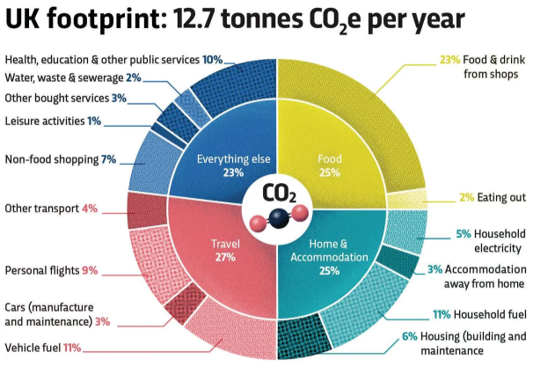
Source: BBC Science Focus and Mike Barners-Lee.
This brings me back to the question I posed earlier: how much is my carbon footprint impacted by my 3 pairs of running shoes a year? With a sense of scale, we can now answer it. Three pairs a year amounts to roughly 32kg CO₂e, about 0.3% of a typical UK footprint. Modest, but not the whole story of a running habit. Add the rest of the gear, an extra load of laundry every couple of weeks, and some contribution to the upkeep of tracks and gym facilities, and you might reach 1–2% of an annual footprint. However, where things get more significant is the additional food intake and, above all, any travel to races.
To illustrate this, consider Kilian Jornet's own carbon footprint, which he has shared publicly on his instagram. The mountain running GOAT logs far more miles than most of us ever will, yet gear accounts for only a marginal share of his total. The dominant factor is mobility, which basically consists of a couple of flights to the US for the Western States 100 miles endurance race (WSER) and his States of Elevation project, plus a flight to Italy to secure his WSER entry. By elite athlete standards, that is remarkably modest travel and the reduction visible in the earlier years of his data likely reflects fewer international races rather than any single lifestyle change.

Figure 4. Evolution of Kilian Jornet’s carbon footprint
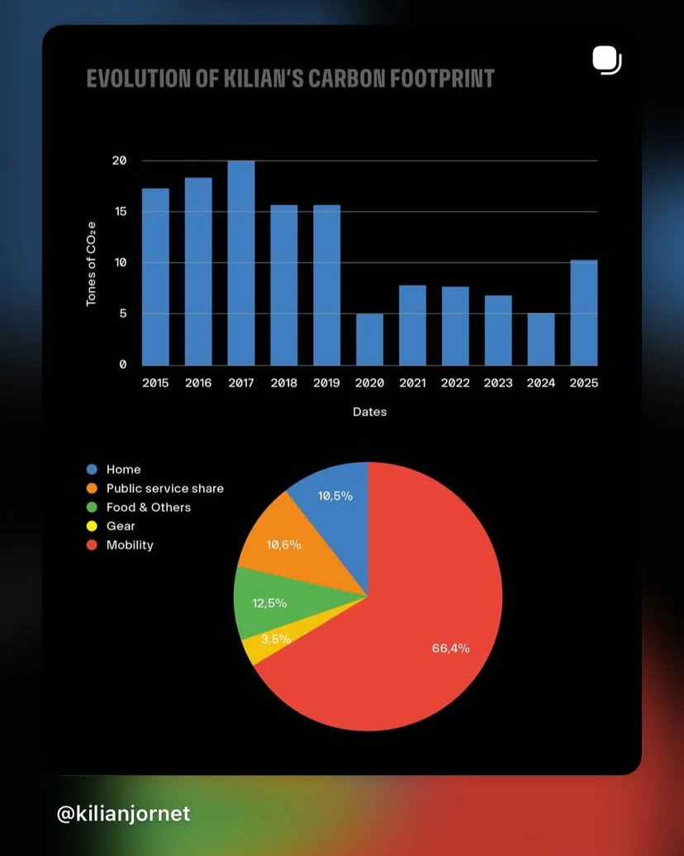
Source: Kilian Jornet.
That said, efforts on other fronts have helped bring his total footprint below the UK average despite travel taking the largest share. As he explained in the Instagram post where he shared his figures, he has been vegetarian for over a decade, drives a second-hand electric vehicle, and buys second-hand through local markets and community groups. And of course, his climate impact extends well beyond his personal footprint: his foundation works actively for the preservation of mountain environments.
Wait… can’t we just blame Taylor?
Why should we "ordinary people" worry about reducing our carbon footprints when some celebrities emit so much more? A few years ago, Taylor Swift was reported to have emitted somewhere between 3,000 and 8,000 tonnes CO₂e from private jet flights alone in a single year, and that was not even a tour year. Leaving aside questions about the accuracy of those figures (she allegedly loaned the aircraft to others, making full attribution debatable) as well as legitimate concerns about privacy and public harassment, it is true that some very wealthy individuals account for a disproportionate share of global emissions.
That said, I do not think this fully absolves the rest of us. For a start, direct emissions comparisons are more complicated than they appear. If I take a flight to visit a friend in Brussels, the enjoyment is largely confined to the two of us. If Taylor Swift flies to give a concert, she is making tens of thousands of people happy. In economics terms, the aggregate utility generated by her flight is orders of magnitude greater than what my trip produces. Strictly speaking, the right metric would be CO₂e per unit of utility — though it is a shame that utils are even less tangible than carbon emissions.
Beyond that, any constructive criticism should come with a proposed alternative. Consider the counterfactuals for Taylor's concert tours:
- She could switch from private jets to commercial flights, which would dramatically reduce emissions per journey by sharing the aircraft with hundreds of other passengers. However, for someone of her profile, this seems genuinely impractical on safety grounds.
- She could replace some flights with other means of transport. That may be feasible perhaps for shorter US legs, but not for transcontinental travel.
- She could concentrate all her concerts in one city. But many fans who would otherwise attend a local show would simply fly to her instead, potentially increasing total emissions.
- Or she could cancel world tours altogether, though that sounds drastic. If you are not a Swiftie, imagine applying the same logic to the Champions League or any major international event you follow. There are, one hopes, less painful paths to decarbonisation.
To be clear, there is plenty of genuine room for improvement. Since many of her flights were not concert-related, some were likely avoidable, and smarter tour scheduling could meaningfully reduce the total flights when touring. However, even if most readers of this article do not sit among the top 0.01%, many of us do belong to the global top 10%. And that group carries more responsibility than we might like to admit.
Good news is there is no need to be climate superheroes
Going vegan, giving up overseas travel, buying only second-hand clothes and building your own home from sustainable materials powered entirely by solar panels can sound a little overwhelming. But the good news is that we do not need to return to living in caves to collectively make a meaningful difference.
Take food, usually one of the most emotionally charged areas. Giving up beef — or reducing it to a very occasional treat — already does a lot of the heavy lifting. Do that, and convince a couple of friends to follow suit, and you may still have to endure your cuñado pointing out your inconsistencies at the family dinner table, but in carbon terms it may have the same impact as going fully vegan on your own. Sounds considerably easier, right?
Takeaways
If you have made it this far, I hope you now have a clearer sense of what actually drives carbon footprints. If you are curious about specific figures, Berners-Lee's book or the ForkRanger Instagram and website are great places to start, and you will find no shortage of carbon footprint calculators online. Bear in mind, though, that all these estimates carry significant uncertainty, and trying to keep an exact record of every gram of CO₂e attributable to yourself is a reliable highway to burnout.
That said, having some sense of scale matters. Berners-Lee shares an anecdote about a colleague who asked whether paper towels or an electric hand dryer were the more environmentally friendly option. The fact that someone is asking that kind of question is genuinely a good sign. But the actual difference is small and depends on so many factors (the country's energy mix, the efficiency of the dryer, whether the paper is recycled, how many towels people use) that it is not where the real battle lies.
Every little action adds up, and there are some genuine no-brainers: recycling, closing the windows if the AC is turned on etc. But we should not be cheating at solitaire. Brushing your teeth with a bamboo toothbrush is fine. Making your things last as long as possible and avoiding unnecessary packaging is actually great. But if you think that doing only these things makes you an exemplary sustainable citizen, that is where self-deception begins.
A question you might still have is: how far do I actually need to go? That is, unfortunately, not easy to answer. Dividing national carbon budgets by population is one possible benchmark, but as I discussed in my article on Carbon Budgets, very few countries have enacted them, and a simple per-capita split misses too much context. More importantly, a significant share of our footprint comes from things largely outside our individual control, starting with the energy mix of the country we live in.
My friend Andrew wrote a thought-provoking piece arguing that we need something like a Ministry of Philosophy to tackle questions such as: what level of risk to the planet are we morally willing to accept in order to maintain our current standard of living? I will leave the institutional design to one side — if I remember anything about the political philosophy lessons I took as an undergrad, it is that one at least should have reservations about that particular proposal — but he raises a genuinely important point. Choosing to reduce your footprint means accepting that others may free-ride on our effort, and giving up some enjoyment for an uncertain collective outcome. That is a real tension, and honest climate communication should not shy away from it.
But that tension is not a reason to give up. Knowing that Europe alone cannot solve climate change does not make European decarbonisation efforts pointless, and the same logic applies at the individual level. My advice is simple: start by understanding how your own footprint is composed and where the largest shares sit. Then pick your battles, focusing on what will make the most impact and what you can realistically change. Do not feel pressured to give up what you genuinely enjoy — instead, look for opportunities in the change itself. Outsmart FOMO and rediscover local landscapes before flying to the other side of the world. Shift towards a healthier diet rich in seasonal produce. Own less stuff you do not really need, and try to buy higher-quality durable goods. You might even find it saves you some money!
Footnotes:

A study carried out by MIT in 2012 found that “the carbon footprint of a typical pair of running shoes made of synthetic materials is 14 ± 2.7 kg CO₂e”. I have bought a couple of pairs of the Superblast 2 model, which came at 12 kg CO₂e per pair, although the second one did not include the carbon footprint label.
There are several methodologies to estimate carbon footprints, such as the bottom-up process-based life cycle analysis, or the top-down environmental input-output analysis, which my colleagues Lucien and Juan Daniel explain in this article estimating the indirect upstream emissions of all sectors in the Spanish economy.
Rice being a relatively high carbon food surprises many, but real solutions exist. My colleagues Vaibhav and Andrew just launched TerraTrack, a business helping smallholder rice farmers significantly cut methane emissions and water use while unlocking high-integrity carbon revenue.
A recent article in Bonpote, an independent French media outlet, pointed out that 80% of the world's population has never flown, so just by flying you are probably already in the top 10% of emitters globally.

